Four Channel Class-D Professional Power Amplifier with DSP+DANTE
(4 × 1500W@8Ω) FDP-41500DT
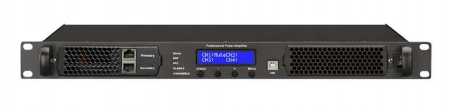
Description:
The 19” rack mount 1RU height design is suitable for universal permanent installation of any sound reinforcement system. The digital Class-D technology also bring the lighter amplifier of less rack space consumption into true, so it is very useful and cost-effective amplifier for installer and system contractor.
The FDP-41500D four channel class-D professional power amplifier rated power output is 4* 1500W@8Ω, build in DSP processor, build in Dante module, so it is design for various installation applications like for government building, stadium, theater and cinema, capacity of each unit maximum connection of four professional sound low impedance

loudspeakers.

Feature:
l Pprofessional power amplifier build in DSP with a better sound
l Build in Dante IP network module.
l Switching power technology digital Class-D level power amplifier.
l Green technology amplifier by 85% efficiency of less power consumption, higher power output, less heat generation and longer life span.
l With PWM special power circuit to ensure excellent cooling system.
l 19” universal rack mount type in 1U height.
l Minimum weight less than 13kgs without transformer technology.
l Support stereo output at 8Ω, 4Ω to 2Ω .
l Rated power output 4*1500W@8Ω,support bridge output
l Input by balanced XLR male connector of 4channels.
l Output by balanced Speakon female connector of 4 channels.
l Complete protection include clip, high temp, overload and short circuit.
l With four fans for cooling down the internal temperature.
l Visual indicator of output level meter, power, protection and clip.
l Comes with 2years qualitywarranty

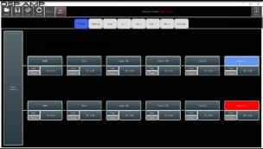

Specification:

Model | FDP-41500DT
Description | Four Channel Class-D Professional Power Amplifier with DSP,DANTE
Amplifier Class | D-Class
Power Output RMS Stereo | 4*1500W@ 8Ω 4*2300W@ 4Ω 4*4600W@ 2Ω
Efficiency | >85%
Frequency Response | 20Hz-20kHz (±0.3dB)@1W, 8Ω
IMD-SMPTE | <0.3%
THD @ 1kHz | <0.1%(20Hz-20kHz ，1W)
Damping Factor @ 8Ω | >1000 @ 8Ω
Slew Rate | 50V/μs
Signal/Noise Ratio | >105dB
Input Sensitivity | 32db, 1V,0.775mv
Voltage Gain | 40dB
Input Impedance | 20KΩ (bal.), 10KΩ (unbal.)
Crosstalk | >75dB
Connector | Input by XLR male, output by Speakon female.
Protection | Clip, high temp, overload and short circuit
Cooling | Temperature controlled fan
Power Supply | AC180V-240V (90V-120V),50-60Hz
Dimension | 44mmX483mmX428mm
Net Weight | 12.5kg

DSP DSP Technical Specifications
f

DSP Specification | Main frequency 294.912MHz, 32-bitDSP processor, sampling frequency 96KHz 24-bitA/D and D/A conversion
LED display | Backlight 2x16 characteristics LCD display
Input impedance | Balanced/unbalanced:20k0/10kΩ
Max input level | + 20dBu(7.75V)
Frequency Response | 20Hz-20kHz (±0.3dB)@1W, 8Ω
Route | Each output channel can choose a different input channel or any combination of input channels
THD @ 1kHz | <0.1%(20Hz-20kHz ，1W)
Gain | Adjustment range:+15dB,- 40dB, 0.1dB per unit
Delay | separately delay control for each input and output channel, and the adjustment range is 0-200ms
EQ | Each input and output channel can be set up 31 equilibriathe EQ way is:PEQ/Lo-Shelf/Hi-Shelf
Input Sensitivity | LPF,HPF PFMode:Link witzRiley/Bessel/Butterworth (Frequency):20Hz-
Limiter | starting time:1ms-100ms.Step;1msRelease time:2 times 4 times.6

32
6
www.ftdaudio.com, info@ftdaudio.com

